**Basic theory**

* Let an image f be represented as an M x N matrix of integer numbers

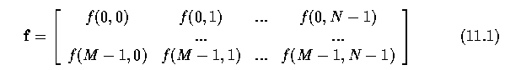

* General transform

http://user.engineering.uiowa.edu/~dip/lecture/LinTransforms/e11.2.gif

* can be rewritten as

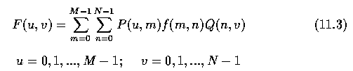

* If P and Q are non-singular (non-zero determinants), inverse matrices exist and

http://user.engineering.uiowa.edu/~dip/lecture/LinTransforms/e11.4.gif

* If P and Q are both symmetric (M=M^T), real, and orthogonal (M^T M = I), then

http://user.engineering.uiowa.edu/~dip/lecture/LinTransforms/e11.5.gif

And the transform is an **orthogonal transform**.

**Hadamard transform**

* The Fourier Transform consists of a projection onto a set of orthogonal sinusoidal waveforms.
* The FT coefficients are called frequency components and the waveforms are ordered by frequency.
* The Hadamard Transform consists of a projection onto a set of square waves called Walsh functions.
* The HT coefficients are called sequence components and the Walsh functions are ordered by the number of their zero-crossings.
* The Walsh functions are real (not complex) and take only the values +1 or -1.
* A Hadamard matrix H_jj is a symmetric JxJ matrix with elements +1 and -1.
* The Hadamard matrix of second order is given by

http://user.engineering.uiowa.edu/~dip/lecture/LinTransforms/e11.22.gif

* A Hadamard matrix of order 2J can be written as

http://user.engineering.uiowa.edu/~dip/lecture/LinTransforms/e11.23.gif

* Hadamard matrices of orders other than powers of 2 exist, but they are not widely used in image processing.
* Inverse Hadamard matrices are easily computed as

http://user.engineering.uiowa.edu/~dip/lecture/LinTransforms/e11.24.gif

* The Hadamard transform and its inverse are given by

http://user.engineering.uiowa.edu/~dip/lecture/LinTransforms/e11.25.gif

* It can be seen that only matrix multiplication is necessary to compute a Hadamard transformation, and further, only additions are computed during it.
* The Hadamard transform is sometimes called a Walsh-Hadamard transform, since the base of the transformation consists of Walsh functions.

**Discrete cosine transform**

* There are four definitions of the [discrete cosine transform](http://en.wikipedia.org/wiki/Discrete_cosine_transform), sometimes denoted DCT-I, DCT-II, DCT-III, and DCT-IV.
* The most commonly used discrete cosine transform in image processing and compression is DCT-II - using equation (11.2) and a square N x N image, the discrete transform matrix can be expressed as

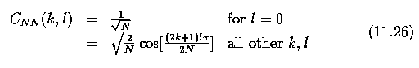

http://user.engineering.uiowa.edu/~dip/lecture/LinTransforms/e11.27.gif

* In the two-dimensional case, the formula for a normalized version of the discrete cosine transform (forward cosine transform DCT-II) may be written

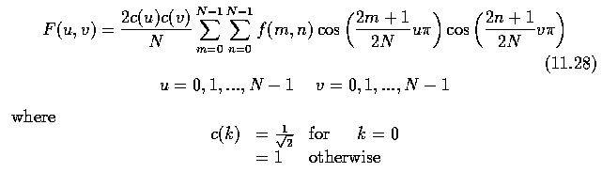

* and the inverse cosine transform is

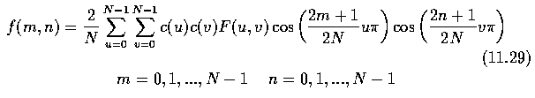

* Note that the discrete cosine transform computation can be based on the Fourier transform - all N coefficients of the discrete cosine transform may be computed using a 2N -point fast Fourier transform.
* Discrete cosine transform forms the basis of JPEG image compression.

**Wavelets**

* Wavelets represent another approach to decompose complex signals into sums of basic functions.
* Fourier functions are localized in frequency but not in space, in the sense that they isolate frequencies, but not isolate occurrences of those frequencies.
* Small frequency changes in a Fourier transform will produce changes everywhere in the time domain.
* Wavelets are local in both frequency (via dilations) and time (via translations) and therefore are able to analyze data at different scales or resolutions better than simple sines and cosines.
* Sharp spikes and discontinuities normally take fewer wavelet bases to represent than if sine-cosine basis functions are used.
* These types of signals generally have a more compact representation using wavelets than with sine-cosine functions.
* In the same way as Fourier analysis, wavelets are derived from a basis function called the Mother function or analyzing wavelet.
* The simplest Mother function is the Haar Mother function shown below.

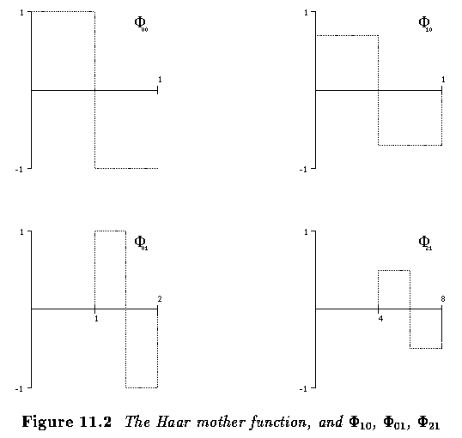

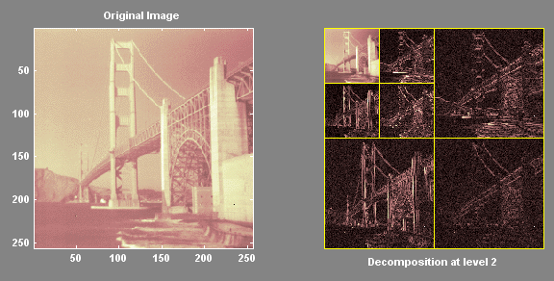

Haar wavelet coefficients. The coefficients in the upper left corner are related to a low resolution image while the other panels correspond to high resolution features.

* Wavelets are often used for data compression and image noise suppression.

Haar wavelet

[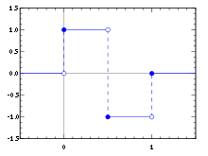](https://en.wikipedia.org/wiki/File:Haar_wavelet.svg)

* In mathematics, the Haar wavelet is a sequence of rescaled "square-shaped" functions which together form a [wavelet](https://en.wikipedia.org/wiki/Wavelet) family or basis. Wavelet analysis is similar to [Fourier analysis](https://en.wikipedia.org/wiki/Fourier_analysis) in that it allows a target function over an interval to be represented in terms of an [orthonormal](https://en.wikipedia.org/wiki/Orthonormal) function basis. The Haar sequence is now recognized as the first known wavelet basis and extensively used as a teaching example.
* The Haar sequence was proposed in 1909 by [Alfréd Haar](https://en.wikipedia.org/wiki/Alfr%C3%A9d_Haar" \o "Alfréd Haar). Haar used these functions to give an example of an orthonormal system for the space of [square-integrable functions](https://en.wikipedia.org/wiki/Square-integrable_function) on the [unit interval](https://en.wikipedia.org/wiki/Unit_interval) [0, 1]. The study of wavelets, and even the term "wavelet", did not come until much later. As a special case of the [Daubechies wavelet](https://en.wikipedia.org/wiki/Daubechies_wavelet), the Haar wavelet is also known as Db1.
* The Haar wavelet is also the simplest possible wavelet. The technical disadvantage of the Haar wavelet is that it is not [continuous](https://en.wikipedia.org/wiki/Continuous_function), and therefore not [differentiable](https://en.wikipedia.org/wiki/Derivative). This property can, however, be an advantage for the analysis of signals with sudden transitions, such as monitoring of tool failure in machines.
* The Haar wavelet's mother wavelet function \psi (t) can be described as
* 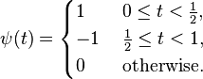
* Its [scaling function](https://en.wikipedia.org/wiki/Father_wavelets) \phi (t) can be described as
* \phi (t)={\begin{cases}1\quad &0\leq t<1,\\0&{\mbox{otherwise.}}\end{cases}}

**Other orthogonal image transforms**

* Many other orthogonal image transforms exist.
* Hadamard, Paley, Walsh, Haar, Hadamard-Haar, Slant, discrete sine transform, wavelets, ...
* The significance of image reconstruction from projections can be seen in computed tomography (CT), magnetic resonance imaging (MRI), positron emission tomography (PET), astronomy, holography, etc., where image formation is based on the Radon transform.

**Applications of orthogonal image transforms**

* Many filters used in image pre-processing were presented - the convolution masks in most cases were used for image filtering or image gradient computation.
* In the frequency domain, such operations are usually called spatial frequency filtering.
* A convolution filter h can be represented by its Fourier transform

http://user.engineering.uiowa.edu/~dip/lecture/LinTransforms/e11.30.gif

(term-by-term multiplication, not a matrix multiplication)

* The filtered image g can be obtained by applying the inverse Fourier transform to G.
* Some basic examples of spatial filtering are linear low-pass and high-pass frequency filters.

Discrete Sine Transformation : Refer from book